Project Design Phase
Solution Architecture
Date | 12 July 2026
Team ID | SWTID-2026-4644
Project Name | Smart Lender
Phase | 3. Project Design Phase

Solution Architecture Diagram
The diagram traces the full request lifecycle of an eligibility check (steps 1–8) alongside the offline model-training pipeline (steps 5–6) that produces the artifacts the live application depends on. This reflects the actual Flask routes, the prediction service, and the notebooks in the Smart-Lender codebase.
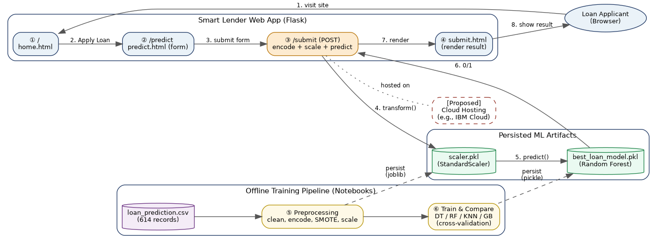
Figure 1: End-to-end Solution Architecture — live prediction path (steps 1–8) and offline training pipeline (steps 5–6).

Architecture Narrative
- Steps 1–2: The applicant opens the Flask-rendered home page and navigates to the loan application form (predict.html).
- Step 3: On submission, the /submit route reads all form fields and manually encodes categorical values to the numeric format the model expects.
- Steps 4–6: The encoded feature vector is scaled with the persisted StandardScaler and passed to the persisted Random Forest classifier, both loaded once at application startup.
- Steps 7–8: The binary prediction is mapped to a human-readable Approved/Rejected message and rendered on submit.html.
- Steps 5–6 (offline): The scaler and model artifacts are produced ahead of time by the notebooks, which clean and encode the dataset, balance classes with SMOTE, and compare four algorithms via 5-fold cross-validation.

Relationship to System Architecture
This document shows the logical/functional flow of a single request. System_Architecture.docx (below) complements this with the physical/infrastructure tiers (web tier, model-serving tier, data tier) needed to deploy and scale this flow in production.

